# SLIDES

1. **Turn On**

* Move the mouse or click the power button to turn on the computer
* Password: joyoftheLord
* Remember: This password is for **our use only**, please do **not** share

1. **Projectors**

* Click on “Safari”
* Open sidebar if the projector options are not already available.
* Click on “Projector East” / “Projector West” / “Projector Central” > “Control” > Turn on (it will take a minute for them to fully turn on)

1. **ProPresenter**

* Open ProPresenter
* Click on ProPresenter application on far left of screen

1. **Tips for ProPresenter**

* You can access the pre-made playlists on the bottom left of the screen
* Remember to click on the desired background **and then** the desired words
* When advancing the slides during worship, click on the arrow to move onto the next slide **on the last or second last word** to prevent going too slow
* You can jump around the playlists by clicking on the sidebar
* Panic Buttons (in top left corner) – Red items are active:

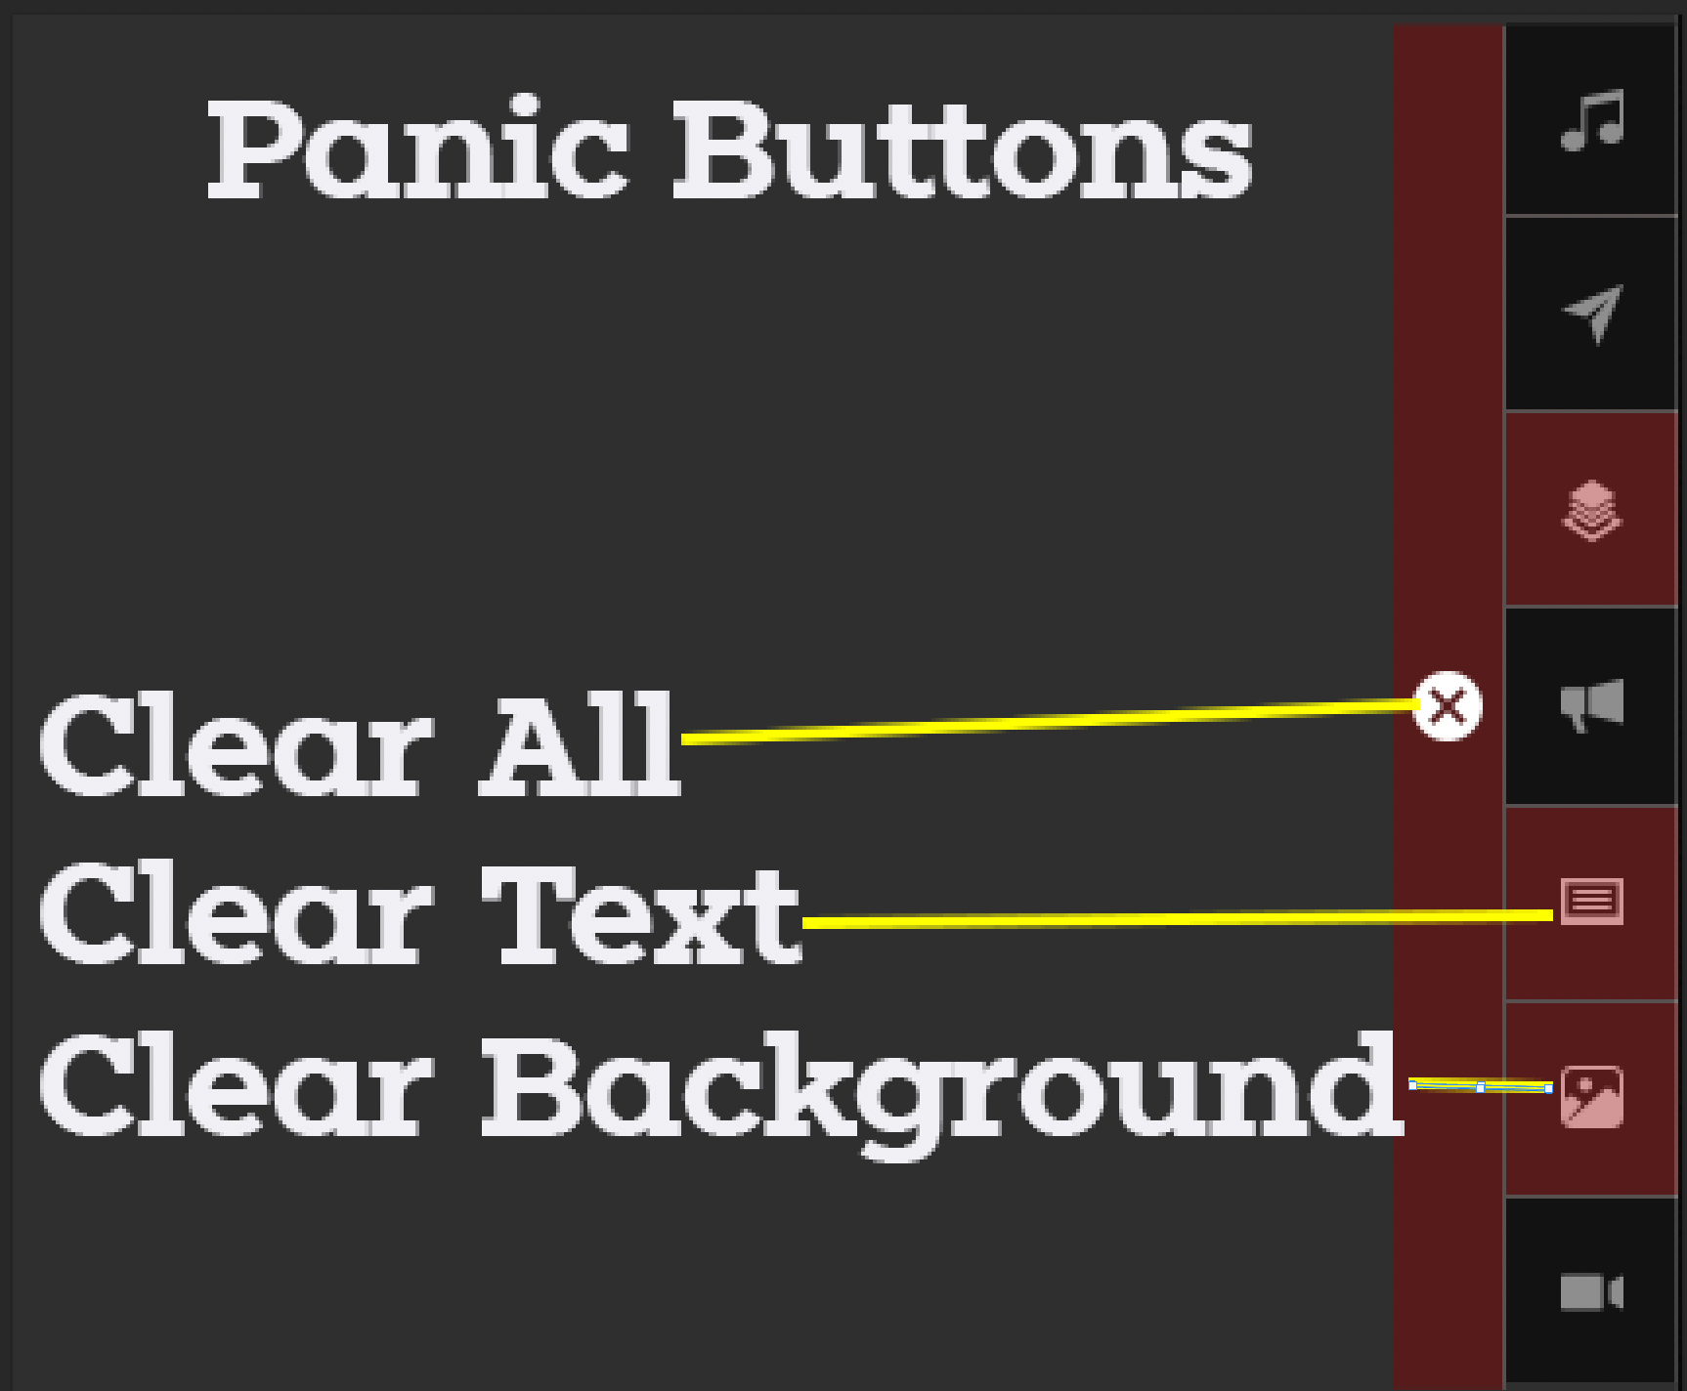

# AUDIO

1. **Setting Up**

* Turn on in the following order: Switch 1, Switch 2, Switch 3, and then the switches on the amp rack
* “Scene 15” = click “15” and then “recall” to bring up the pre-set six mics needed for camp

1. **Using Mics**

* Turn on with on switch
* 2 bars of battery is the minimum amount of battery level. Extra batteries are across from sound board
* Numbers on mic corresponds to mic numbers on the sound board

1. **Controlling Mics**

* Turn mic on by pressing the button above each of the mic numbers on the sound board
* To prevent feedback, turn down volume on soundboard
* In there are only 2-3 people on stage, turn mic volume down

1. **Computer Sound**

* Computer sound is on the far right and should only be turned up about halfway
* Computer sound should always be on but can be turned down when not in use

1. **Turning Off**

* Turn off sound board in the following order: Amp rack swtiches, and then Switch 3, Switch 2, Switch 1